Dated 16-3-2024

Please refer <https://apespl.in/> to use idea of type of home page scrolling pictures & text.

In Home – Please remove video & add 3 photos (in auto scroll mode) in following hierarchy.

1. <https://www.macvalves.com/products-all/> (Use this photo)

# (*Tag line on photo – Use suitable color combination)

# WELCOME to **S S AMALGUS** (A TECH PRODUCT CO) PART OF **S S GROUP** SINCE 1980.

##### **INDUSTRIAL AUTOMATION SOLUTION PROVIDER**

**MAC VALVES** for all your Pneumatic Applications. (Quality Engineered for Speed & Reliability)

1. <https://www.norgren.com/en> - Robotic Arm (Current picture blurr)

# (*Tag line on photo – Use suitable color combination)

**Unlocking Sustainable Future Through INDUSTRIAL AUTOMATION.**

1. <https://www.pisco.com/> (Already correct picture)

# (*Tag line on photo – Use suitable color combination)

**High Quality PNEUMATIC EQUIPMENTS.**

Correct Linked in Link <https://www.linkedin.com/feed/?trk=homepage-basic_sign-in-submit>

# If You Have Any Query, Please Contact Us

Add – Company Name -

Contact Mobile number –   
I'm not a robot. reCAPTCHA

In ABOUT US – The Background photo to be selected from the either of 2 PDF files.

KEEP TEXT

#### More then your VENDOR, WE BECOME YOUR MANUFACTURING PARTNER !!

In About us – Mahendr Shah ~~–and @ 650 delighted customers today.~~

Hide - We at S S AMALGUS, explore Product Solution & redefine efficiency thru optimization by using the best technological solutions. From standard components to complex turnkey tailor-made equipment, we collaborate with your teams to optimize solutions which integrate perfectly into your system to increase performance. All of our selected partners are known for unique technologies, experiences and passions for innovation in their specialties.

###### Commitment

We take Ownership and trust build Over **50+** years of serving & business association.

(Correction in bold)

###### Commitment

We take Ownership and trust build over **50+ years** of serving & business association.

(Correction in bold)

Once the site changes are done, we will have one online discussion.

Also please share the login / password details for records.

When Trident page is clicked – Only Trident LOGO & Products details to be seen.

Background phot is OK.

In place of OTHER PRODUCTS : **TRIDENT - Engineering Quality AIR & GAS**

<https://www.tridentpneumatics.com/compressed-air-dryers.php>

In Nucon – page is clicked – Only NUCON LOGO & Products details to be seen.

For background picture <https://www.istockphoto.com/photo/various-type-pneumatic-equipment-e-g-air-cylinder-and-rotary-pneumatic-cylinder-gm1366800108-437230099?utm_campaign=srp_photos_limitedresults&utm_content=https%3A%2F%2Fwww.pexels.com%2Fsearch%2Fpneumatic%2520lubricator%2F&utm_medium=affiliate&utm_source=pexels&utm_term=pneumatic+lubricator>

**Pneumatic Cylinders, Filters & Accessories.** <https://nucon.net/inside/cylinders.php>

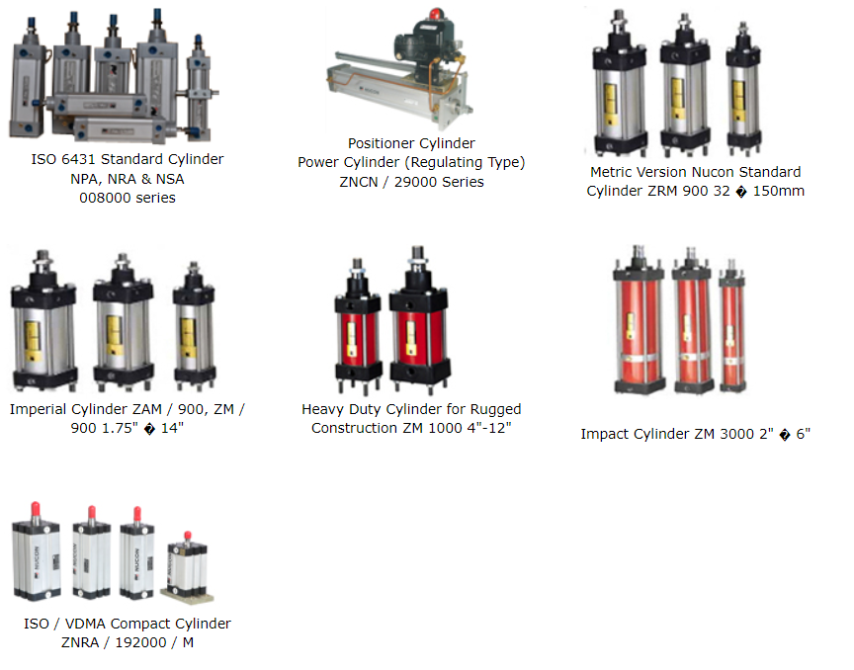

In BAILEY & mackey– page is clicked – Only & Products details to be seen.

In background photo -

<https://www.baileymackey.com/>

Bailey & Mackey is a well-established family owned business which is proud to have established a worldwide reputation for providing a high quality products which are reliable in service. We have been manufacturing high quality instrumentation for over 70 years. The product range has been extended over the years and we now manufacture Pressure Switches, Pressure Gauges and Pressure Transducers all made in our factory in Birmingham.

Their Core design enables our products to be easily adapted to meet specific customer requirements, this enables us to satisfy the requirements of a widely diverse industries including Fire Safety, HVAC (Heating & Ventilation), Medical, Waste Water, Chemical, Automotive and Food. We pride ourselves on suppling high quality and reliable products to almost all industries.

* 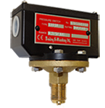
* Type 1381
* Diaphragm Operated
* Ranges from -1 to 40 bar
* Static Pressure



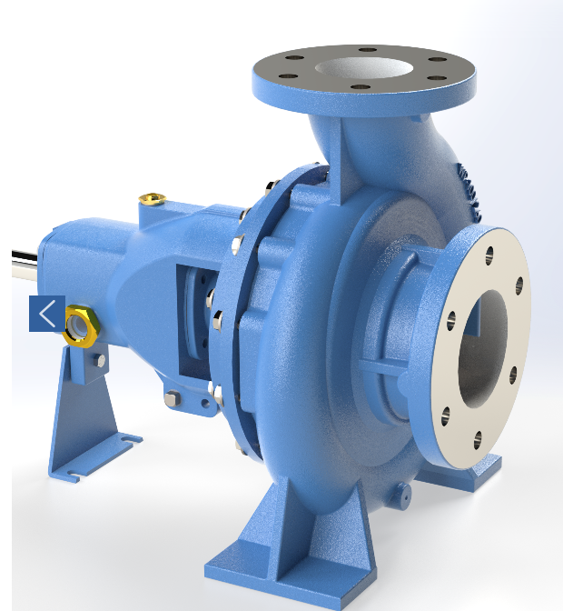

<https://www.keerthipumps.com/>

KEERTHI Pumps is renowned for manufacturing the highest quality Industrial pumping and utilizing the best engineering practices available worldwide..

<https://www.keerthipumps.com/products/>

